**Project Proposal:** Elevating the Movie-Watching Experience

**Problem Statement:**

The landscape of contemporary movie-watching platforms often lacks the vital elements of engagement, personalization, and real-time interaction. Users frequently encounter difficulties in discovering movies that cater to their unique tastes and preferences, and the absence of immediate connection with other viewers during movie-watching detracts from the overall experience.

**Proposed Solutions:**

User-Generated Playlists

**Problem Addressed:** Limited movie discovery tailored to individual preferences.

**Solution Overview:** Implement user-generated playlists, empowering users to craft curated collections of movies that resonate with their distinct interests and moods.

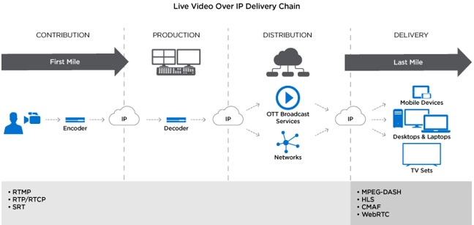

**Key Features:**

-**AI-Enhanced Recommendations:** Leverage advanced machine learning algorithms to provide personalized movie suggestions based on user preferences and viewing history.

- **Collaborative Playlist Creation:** Foster a sense of community by enabling users to create and share playlists collaboratively.

-**Customization:** Empower users to fine-tune playlist content and order to align precisely with their unique tastes.

**Real-Time Chat**

**Problem Addressed**: The absence of live interaction and discussion during movie-watching.

**Solution Overview:** Incorporate real-time chat features, enabling users to connect, converse, and share their movie-watching experiences in the moment.

**Key Features:**

- **Synchronized Viewing:** Facilitate communal movie-watching experiences, allowing users to watch films together while engaging in real-time chat.

- **Thematic Group Chats:** Create dedicated chat spaces for specific genres, movies, or user-defined interests.

- **Intelligent Chatbots:** Enhance engagement with AI-driven chatbots that offer movie-related trivia, recommendations, and conversation starters.

**Implementation Plan:**

**- Timeline:** Develop a comprehensive timeline outlining key milestones and deadlines for feature implementation.

- **Resource Allocation:** Allocate the necessary resources, including development teams, design experts, and quality assurance personnel.

**- Testing and Validation:** Execute rigorous testing of user-generated playlists and real-time chat to ensure a seamless, high-quality user experience.

**Cost-Benefit Analysis:**

- Calculate development costs, ongoing maintenance expenses, and projected revenue gains resulting from heightened user engagement and increased subscriptions.

**Risk Assessment:**

- Identify potential risks, such as scalability challenges with real-time chat, and detail proactive mitigation strategies.

**Documentation:**

- Thoroughly document the entire development process, capturing design rationale, user feedback, and testing outcomes.

**Presentation and Assessment:**

- Prepare a compelling presentation to showcase the innovative solution to stakeholders or assessors, emphasizing how it enriches the movie-watching experience while effectively addressing identified issues.